Initiation Date: 2014.12.01 |  |  |  | SKIPPER Electronics AS |  |  |  |  | Document no.:  QS-09  Project Test Report Template
Test-sensor:  121479 |  | Project Test Report  50 bar test of EML224S
Author: S.Theodorsen |  | Test rev. |  |  | Rev. date: |  | Template rev.:
 |  | A |  |  | 2010.01.25 |  | 1
Phase | Appr date | Phase | Appr date |  | Phase | Appr date
Start date 2014.12.05 |  | Pre-release test |  |  | Release  test

TABLE OF CONTENTS

1 Test definition 1
2 Test results 2

Test definition
We want to function-test our EML224S for deeper water. Our objective is to find out if it would be operative in 50 bar.

Equipment: 1 pcs manual pump, REMS Push
2 pcs manometers, 0-60 bar
1 pcs pressure tank, AISI 316 Tank
1 pcs EML224S sensor, SKIPPER Electronics AS
1 test jigg, SKIPPER Electronics AS

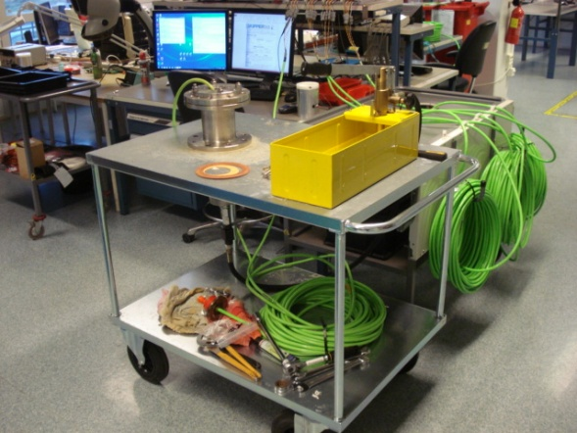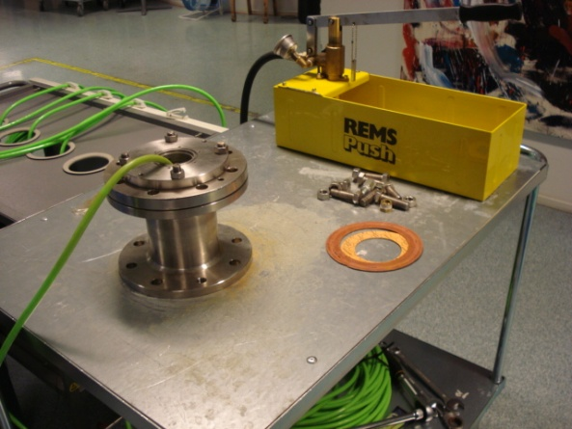

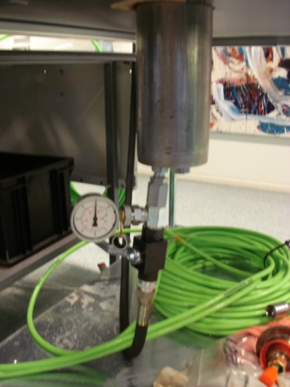

Test results

Date | Pressure | Ch 1 | Ch 2 | Offset
2014.12.05 | 30 | 6,32 | 6,32 | 16,3/-8/0,7
2014.12.06 | 25 | 6,32 | 6,32 | 16,3/-8/0,7
2014.12.07 | 25 | 6,32 | 6,32 | 16,3/-8/0,7
2014.12.08 | 50 | 6,32 | 6,32 | 16,3/-8/0,7
2014.12.09 | 50 | 6,32 | 6,32 | 16,3/-8/0,7
2014.12.10 | 35 | 6,32 | 6,32 | 16,3/-8/0,7
2014.12.11 | 50 | 6,32 | 6,32 | 16,3/-8/0,7
2014.12.12 | 45 | 6,32 | 6,32 | 16,3/-8/0,7
2014.12.15 | 50 | 6,32 | 6,32 | 16,3/-8/0,7
2014.12.17 | 50 | 6,32 | 6,32 | 16,3/-8/0,7
2014.12.19 | 50 | 6,32 | 6,32 | 16,3/-8/0,7
2014.12.22 | 30-50 | 6,32 | 6,32 | 16,2/-7,5/0,4
2014.12.23 | 48-50 | 6,32 | 6,32 | 16,2/-7,5/0,4
2014.12.29 | 30-50 | 6,32 | 6,32 | 16,2/-7,5/0,4
2014.12.30 | 30-50 | 6,32 | 6,32 | 16,2/-7,5/0,4
2015.01.02 | 40-50 | 6,32 | 6,32 | 16,2/-7,5/0,4
2015.01.05 | 40-50 | 6,32 | 6,32 | 16,2/-7,5/0,4
2015.01.07 | 40-50 | 6,32 | 6,32 | 16,2/-7,5/0,4
2015.01.08 | 45-50 | 6,32 | 6,32 | 16,2/-7,5/0,4

